**Sennheiser to Showcase Latest Audio Innovations for Content Creators at Bild Expo**

***Sennheiser Empowers Filmmakers and Content Creators with Cutting-Edge Audio Solutions at New York City Event***

**New York, NY — June 9, 2025—** [**Sennheiser**](http://www.sennheiser.com)**, the brand building the future of audio since 1945, will be showcasing its range of trusted audio solutions for filmmakers and content creators at Bild Expo 2025, taking place at the Javits Center in New York City from June 17-18. Bild Expo hosts the largest gathering of photographers, content creators, and filmmakers, catering to attendees of all interests and experience level in the industry. Sennheiser will exhibit its latest audio tools designed to empower all types of content creators, emphasizing clarity, reliability, and ease of use at Booth 1160.**

“Sennheiser is excited to connect with the spirited community of photographers, filmmakers, sound mixers, and creators of all kinds at the Bild Expo. This free event promises to be beneficial whether you’re just getting your footing in the field, or a seasoned industry professional,” said Ed Capp, Vice President, Sales, Americas at Sennheiser. “We’re looking forward to highlighting several solutions like Profile Wireless and EW-DP, designed to make professional sound more accessible than ever. In June, Sennheiser will also celebrate our 80th anniversary of audio innovation, and we’re excited to celebrate this accomplishment in conjunction with Bild Expo.”

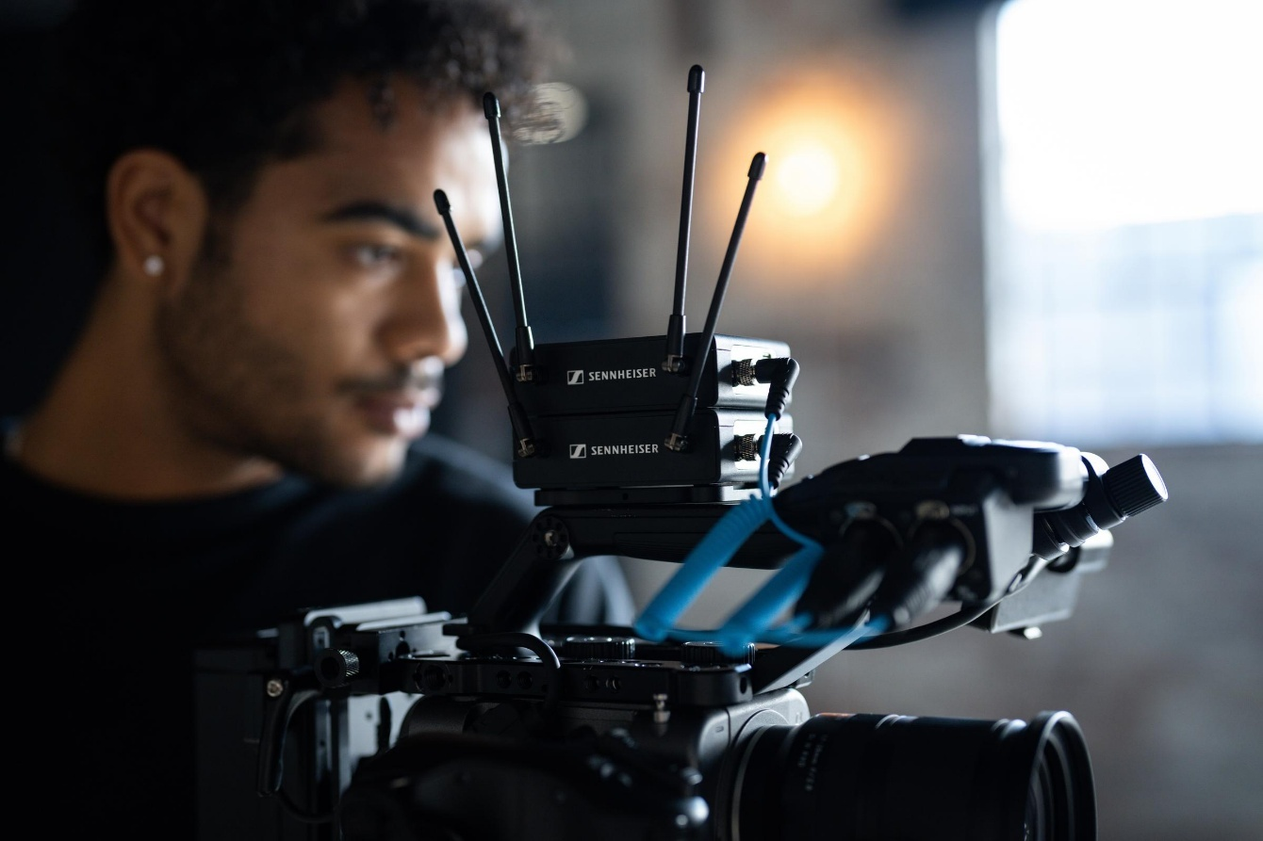Sennheiser’s EW-DP is a fully digital UHF wireless microphone system with a new portable design and unmatched audio quality.

The Sennheiser booth will showcase and offer demos of the Profile Wireless 2-channel set, the Profile Wireless 1-channel Set, MKH 8018, MKH 416, MHK 8000 series shotgun microphones, and EW-DP. Select Neumann products, including the MT 48 to enable demos of a range of microphones and headphones, will also be on display, showcasing the unparalleled precision synonymous with the Neumann brand.

Some principal features of the products to be showcased include:

* **Profile Wireless –** Available as either a two-channel or 1-channel set, this 2.4 GHz all-in-one microphone system provides videographers with everything they need to effortlessly capture high-quality audio. It connects to mobile phones, cameras or computers, and can be used as a clip-on mic, handheld mic or table-top microphone. Now with 32-bit float recording, creators can record with extremely high dynamic range, and help them recover clipped audio.
* **MKH 8018** - The high-class shotgun microphone completes the company’s MKH 8000 range of RF condenser microphones, which excel in the field due to their climate-proof ruggedness and natural sound capture with virtually no off-axis coloration.  Providing flexibility to the audio engineer, it features three switchable stereo modes: MS stereo, wide XY stereo and narrow XY stereo.
* **MKH 416** - For 50 years, the MKH 416 has accompanied broadcasters, filmmakers, voice-over artists, and content creators, being used both in studios and in the field. Mounted onto a boom pole, a stand or a camera, its job has been to stay outside the camera angle while gracefully capturing sound with clarity and impact.
* **EW-DP** - Purpose-built for content creators, filmmakers, and broadcasters, EW-DP is a fully digital UHF wireless microphone system with a new portable design and unmatched audio quality. At its heart is a compact, intelligent receiver that helps even novice users set up their audio with ease.



Profile Wireless, a 2-channel, 2.4 GHz all-in-one microphone system, provides videographers with everything they need to effortlessly capture high-quality audio.

Media and influencers can loan a limited quantity of Sennheiser products at Bild Expo. Available products include the Profile Wireless (1 or 2-channel sets) and the EW-DP ENG Set with e835 microphones, and must be reserved in advance of the expo. This unique opportunity allows participants hands-on experience with leading-edge audio solutions to capture high quality content on the show floor.

For more information on Sennheiser, please visit Sennheiser.com.

###

**About the Sennheiser brand**

We live and breathe audio. We are driven by the passion to create audio solutions that make a difference. In 2025, the Sennheiser Group celebrates its 80th anniversary. Since 1945, we stand for building the future of audio and bringing remarkable sound experiences to our customers.

Today, the Sennheiser Group is one of the leading manufacturers in the field of professional audio technology. With our unique brands Sennheiser, Neumann, AMBEO and Merging, we offer a comprehensive range of solutions that is fully tailored to the needs of our customers. The independent family-owned company is managed in the third generation by Dr. Andreas Sennheiser and Daniel Sennheiser.

www.sennheiser.com

[www.sennheiser.com](http://www.sennheiser.com)

[www.sennheiser-hearing.com](http://www.sennheiser-hearing.com)

**Local Press Contacts**

Daniella Kohan

[daniella.kohan@sennheiser.com](mailto:daniella.kohan@sennheiser.com)

+1 (860) 227-2235

Kirsten Spruch

[Kirsten.spruch@sennheiser.com](mailto:Kirsten.spruch@sennheiser.com)

+1 (860) 598-7484

Miranda Warren

Miranda@ingearpr.com

+1 (631) 681-7475